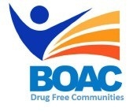

MBroeomet OipioidgAwareness Council

December 7th , 2018 | 10 a.m. - 12 p.m.

Conference Rooms B&C • Broome County Health Department

**Agenda**

**Call to Order:** Marissa Lamphere, Broome County Opioid Overdose Prevention Coordinator

**Welcome and Introductions**

1. **Approval of November Meeting Minutes**
2. **Lourdes Youth Services Program Overview-**
3. **Debra Kerins – Retired & Senior Volunteer Program (RSVP) Project Director**
4. **Committee Updates:**

* Broome County Prevention Coalition (Formerly Community Education)
* Media and Advocacy Committee
* Peer Response & Law Enforcement Committee
* Treatment and Prevention Committee
* Data and Statistics Committee
* Rural Committee

1. **Other Announcements/Business**

**Next Meeting: Friday January 4th 2019 10am-12pm BCHD**