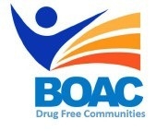

MBroeomet OipioidgAwareness Council

September 13, 2019 | 10am-12pm

Conference Rooms B&C • Broome County Health Department

**Agenda**

**Call to Order:** Rebecca Kaufman – Broome County Public Health Director

**Welcome and Introductions**

1. Data & Statistics update: Dr. Christopher Ryan – Medical Director Broome County Health Department
2. Partner updates/announcements – Recovery Month happenings
3. Sub Committee Updates

* Broome County Prevention Coalition (Formerly Community Education)
* Media and Advocacy Committee
* Peer Response & Law Enforcement Committee
* Treatment and Prevention Committee
* Rural Committee

**Next Meeting:** Friday October 4th 10am- Broome County Health Department