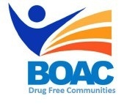
MBroeomet OipioidgAwareness Council & Drug Free Communities

November 2, 2018 | 10 a.m. - 12 p.m.
Conference Rooms B&C • Broome County Health Department

Agenda

Call to Order: Marissa Lamphere, Broome County Opioid Overdose Prevention Coordinator

Welcome and Introductions

- Approval of October 5th, 2018 Meeting Minutes

- Ray Serowik- 911 Overdose and related calls

- Committee Updates:
- Broome County Prevention Coalition (Formerly Community Education)
- Media and Advocacy Committee
- Peer Response & Law Enforcement Committee
- Treatment and Prevention Committee
- Data and Statistics Committee
- Rural Committee

- Other Announcements/Business

Next Meeting: Friday December 7, 2018

