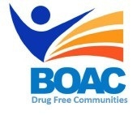
MBroeomet OipioidgAwareness Council

April 5th, 2019 | 10am-12pm
Conference Rooms B&C • Broome County Health Department

Agenda

Call to Order: Marissa Lamphere- Opioid Overdose Prevention Coordinator

Welcome and Introductions

- Bouakham Rosetti- Project Manager Care Compass Network

- Committee Updates:

- Broome County Prevention Coalition (Formerly Community Education)

- Media and Advocacy Committee

- Peer Response & Law Enforcement Committee

- Treatment and Prevention Committee

- Data and Statistics Committee

- Rural Committee

- Other Announcements/Business

Next Meeting: July meeting cancelled due to holiday, we will meet again at 10am on Friday 8/2

